Software Requirements Specification

**Prepared by:**

**Muhammad Faraz Ansar (NEDUET)**

**Afnan Hassan (NEDUET)**

**26/02/2020**

# INTRODUCTION

## PURPOSE OF REQUIREMENT DOCUMENT

This Software Requirements Specification provides a complete description of all the functions and specifications of the admin of the website and customer.

It will explain the purpose and features of the system, the interfaces of the system, what the system will do, the constraints under which it must operate.

The main purpose of this software is to provide online shopping facility to the students, parents, companies and schools, so that they can buy all kinds of stationery stuffs and furniture for schools and companies. The website will provide all kinds of online payment methods.

## PROJECT SCOPE

* **Description**

This software product can facilitate a person who wants to buy stationery stuff like school bags, bottles, pen, paper, ink and all the stuffs like that. It can also facilitate the management of school who wants to buy stationery items and furniture for themselves. The project scope is also in banking sector which can enhance their market shares by providing latest payment methods like easy paisa, jazz cash, credit card etc. it can also provide electronic equipments like attendance machine, study lamp, call system and other things like that, to the schools and companies which want them. Its scope is also in library sectors because it can also provide all kinds of course books.

* **Benefits**

There are number of benefits of this E-Commerce website:

* Customers can buy pen, paper, pencil, calculator and all kinds of latest stationery items online.
* Schools can buy all stationery items as above with additional items like study room furniture like chairs, black and white board etc online.
* Schools and other companies can also buy electronic equipments like attendance machine, electric bell, caller, phones etc online.
* Customers can use latest payment methods like credit card, easy paisa, jazz cash etc.
* Customers can call, WhatsApp, text message the dealer.
* Customers can print the receipt online for security issues.
* The delivery will be offered by the dealer. Customer can also pay the cash on delivery.
* You can track your order and dealer will notify you about every move.
* **Corporate Goals**

There can be following goals of the system:

* To start the business of all stationery items.
* To provide the customers online shopping facility so that they can buy every thing by sitting at their homes.

## DEFINITIONS, ACRONYMS & ABBREVIATIONS

* **SQL Server**

SQL stands for Structured Query Language

SQL is a [database](http://en.wikipedia.org/wiki/Database) computer language designed for managing [data](http://en.wikipedia.org/wiki/Data) in [relational database management systems](http://en.wikipedia.org/wiki/Relational_database_management_systems) (RDBMS), and originally based upon [relational algebra](http://en.wikipedia.org/wiki/Relational_algebra) and [calculus](http://en.wikipedia.org/wiki/Relational_calculus). Its scope includes data insert, query, update and delete, [schema](http://en.wikipedia.org/wiki/Database_schema) creation and modification, and data access control.

* **ASP.NET MVC**

ASP stands for ACTIVE SERVER PAGES and MVC stands for MODEL-VIEW-CONTROLLER

The **ASP.NET MVC** is a discontinued WEB APPLICATION FRAMEWORK developed by Microsoft, which implements the [model–view–controller](https://en.wikipedia.org/wiki/Model%E2%80%93view%E2%80%93controller) (MVC) pattern.

* **ADMIN**

ADMIN stands for Administration

ADMIN means to work for Organization, Controlling the operation itself in the Company by Adhering the Policies of Company.

* **FRONT END**

Front End of the website contains all the interfaces and forms that which user will interact.

* **BACK END**

Back End of the website contains all the database and functionality implementation that make the front end useful for the user and organization as well.

* **CENTRALIZED SERVER**

A type of [network](http://www.webopedia.com/TERM/N/network.html) where all users connect to a central server, which is the acting agent for all communications. This server would store both the communications and the user account information. Most public [instant messaging](http://www.webopedia.com/TERM/I/instant_messaging.html) [platforms](http://www.webopedia.com/TERM/P/platform.html) use a centralized network. Also called *centralized server-structure*.

* **OOP**

**OOP stands for object oriented programming**

The programming style where all the things and functions are consider as objects. The main features are inheritance, abstraction, polymorphism, method overriding, and encapsulation.

* **SEO**

SEO stands for search engine optimization

It is the process of getting traffic from “free”, “organic”, and “Natural” search results on search engines.

* **TECHNICAL SUPPORT TEAM**

User-friendly assistance for individuals having technical problems with hardware devices and software issues. The technical support team is composed of we (developers) that are familiar with the ins and outs of a cloud technologies. With this knowledge, we are able to troubleshoot most problems that a user experience. Information on how to reach technical support is usually provided with the free services with 20 days of working. Technical support may be provided over the phone, through email, or with a live-chat interface. Our contact and policies will be on the bottom of the website.

* **GENERAL DESCRIPTION**

## PRODUCT PERSPECTIVE

The product is supposed to be an open source, under the GNU general Public License. It is a web-based system implementing client-server model. This website provides simple mechanism for customers to buy the stationery items whatever they want to buy.

The following are the main features that are included in our system:

* **Cross platform support:** Offers operating support for most of the known and commercial operating systems.
* **User account:** The system allows the user to create their accounts in the system and provide features of updating and viewing profiles.
* **Admin account**: The admin can login through the same login panel. We will connect user-login table and admin-login table to the same form by logic. The admin will be given maximum rights in the website like searching the customer, deleting the customer, add the customer and update the customer and many more rights.
* **Forgot password**: customer will get the password on his/her email, if forgot after authentication.
* **Number of users being supported by the system:** Though the number is precisely not mentioned but the system is able to support a large number of online users at a time.
* **Add to cart**: The customer can add more than one items to the cart at a time.
* **Payment methods:** The customers can use modern payment methods.
* **FAQs section:** Frequently asked section contains answer of problem which our donors frequently faced.
* **Review:** customer can add review about the services and products they bought.
* **Custom order:** The customer can request for custom order which is not mentioned in the website. If it will available, the dealer will let him/her know.
* **Coupon for discount:** The can get discount, if he gets the voucher after authentication.
* **Company registration:** There will the registration facility of the companies and school management so that they can get benefit from the website

* **CLASS DIAGRAM**

We will be having different classes and interface following .

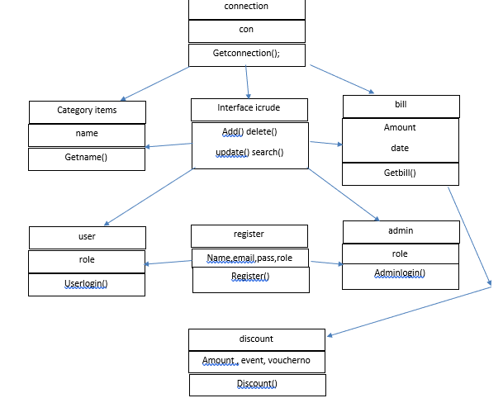

The class diagram may vary during development due to requirement volatility.

## GENERAL CONSTRAINTS

## Hardware Limitations

Hardware limitation of this software product can be unavailability of network. If network devices and proper LAN connections are not available then the Organization can’t use the software to monitor systems. We have no responsibility of hardware failure because we have developed the software.

## Security Consideration

Security issues can be that if any User or any company use Email of other person. If the user has entered invalid data in any field it will get an error message. If the user has forgotten the password it will send to user by an email in a very secure manner.

# SPECIFIC REQUIREMENT

## FUNCTIONAL REQUIREMENT

## For customer

1. The customer will login to the system by entering Email and password. If the customer is new to the website then he/she should register himself/herself.
2. If the customer forgot password, then there should be password recovery.
3. The customers can buy anything mentioned (stationery items) in the website. If he/she wants the things which are not mentioned then there should a custom order option.
4. If the customer is the company or school then there should a separate account for them.
5. There should be delivery facility option.
6. Can generate voucher for safety issues.
7. There should be online payment methods including cash on delivery.
8. Can view cart.
9. Can track order and shipment.
10. Can change or update address.
11. Can call through number, WhatsApp, Facebook etc to the dealer or admin.
12. Can comment or review the order, services and constraints.
13. Can view his past orders list

* **For Admin**

1. Can login/register himself
2. Can check the orders
3. Can update, delete, search, insert the customer
4. Can reply for the reviews and queries
5. Can insert the pictures, prices of the items in their respective categories.
6. Can view custom orders.

## NON-FUNCTIONAL REQUIREMENTS

* **Product Requirements**
* **Usability**

Since, we will implement the complete object-oriented programming that’s why our code will be reusable whenever we can.

* **Reliability**

Its analysis testing procedures that allows previewing of website service cost. Our website can be used throughout for a wide range of time. It would carry on working without any failure. We will apply unit testing and integration testing to the website at the end before deployment. After deployment we will also provide beta testing in which user of the system and Admin will test the system.

## Performance

It is an open source website. It can create powerful, realistic work for thousands of users surfing through the website. The website will respond to user request within 2 seconds if user wants to see the graphical analysis enlarged it will immediately display it to user.

* **Efficiency**

Our website provides easy to use tools that any user or an organization can access. The website is appropriate and well managed. User login will not take much time. It will operate quickly with acceptable system performance.

* **Portability**

Our website can run on the environment that support network domain like Google Chrome(for mobile application) and Torch, Mozilla Firefox etc .The web layout may vary on different devices

* **External Requirements**
* **Ethical**
* The user will not find any odious data in the software.
* The software’s abusive and fake usage will highly be condemned.
* **Safety**

No such heavy downloadable in the software which can lead to system crash.

## Security

No external user is allowed to make changes in the software, only administrator can make changes. The whole login time should not take much time and the password entered by the administrative person display as ASCII character”*”.

## TECHNOLOGY OF DEVELOPMENT

* **FRONT END**

For front end of our website, we will use **html5, CSS3, JavaScript and bootstrap4.** Other libraries and languages can be use depend on the requirement.

* **BACK END**

For back end of the website, we will use **ASP.NET MVC** architecture with **C#** as programming language.

Since, we will apply **OOP** in our website, so its response time will be very fast.

* **DATABASE**

**SQL Server 2012** will be used for storing database. The system must provide SQL data table definitions and all commands used in **SQL Server 2012.**

* **SEARCH ENGINE OPTIMIZATION**

**For SEO**, we will use a website **“smallseotools.com”** .

* **SOFTWARE COST ESTIMATION**
* **EFFORT**

**Lines of code = 6 KLOC** (including both front end and backend approx., it may vary)

6KLOC = 6000 lines of code

Using COCOMO MODEL, we have

EFFORT = a (KLOC)b

Using semi-detached development mode, we have

a = 3.0 and b = 1.12

After calculation we have;

**EFFORT = 22.31 persons-month**

* **DEVELOPMENT TIME**

We have;

Tdev = c (effort)d

As;

c = 2.5 and d = 0.35

After calculation we have;

**Tdev = 7.411 months**

**But we will deliver the system in 6 months**

* **COST**

**We want 10,000 RS per month, With the submission of the whole month’s work**

* **PROJECT PLAN**
* **PHASE-1**

The phase-1 contains the following tasks:

* **Front end development i-e design the VIEW container of MVC**
* **Design the website, a rough sketch**
* **Understanding complete requirements**

**DURATION: The above tasks will take almost 1 month to complete.**

* **PHASE-2**

The phase-2 contains the following tasks:

* **Database design including all tables with relationships.**
* **Designing ERD diagram**
* **Connection of database with the project**
* **Design the model container of MVC**
* **Add all the relevant classes in the model container**
* **Applying all the OOP concepts in the classes**

**DURATION: The above task will take almost 2 months to complete.**

* **PHASE-3**

The phase-3 contains the following tasks:

* **The actual coding and logics i-e backend development**
* **Testing and optimizing response time**
* **Applying SEO (search engine optimization)**

**DURATION: The above task will take almost 2 months to complete.**

* **PHASE-4**

The phase-4 contains the following tasks:

* **Testing before deployment i-e unit testing and integration testing**
* **Testing after deployment i-e alpha and beta testing**
* **Hosting the website**

**DURATION: The above task will take almost 1 month to complete.**

* **GANTT CHART OF THE PROJECT**

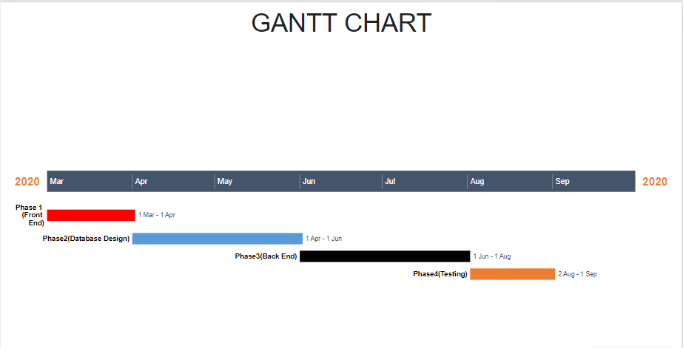

# SYSTEM MODELING

# CONTEXT MODEL

# 

# USER-CASE MODEL

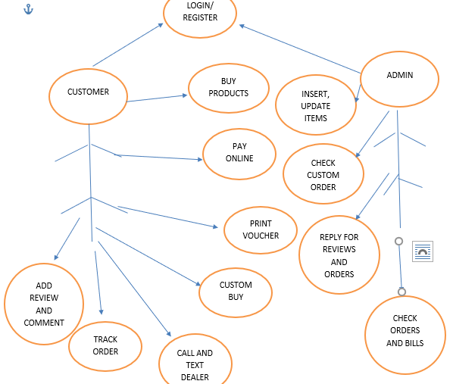

# DATA-FLOW DIAGRAM FOR CUSTOMER

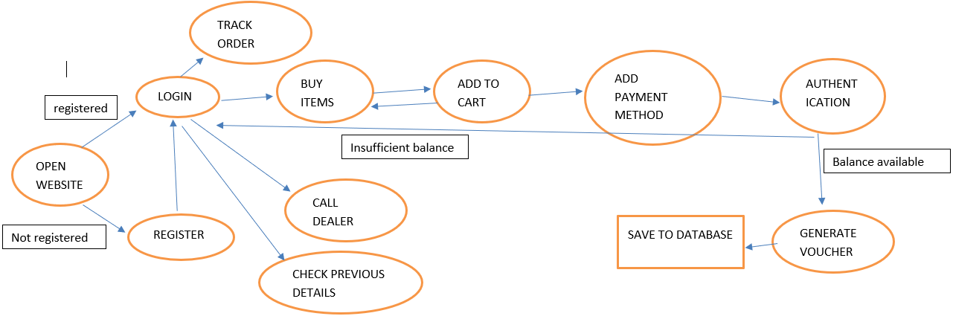

* **ABOUT THE DEVELOPERS**
* **MUHAMMAD FARAZ ANSAR (JUNIOR SOFTWARE DEVELOPER)**

I am the student of second year **software engineering** in **NED university of engineering and technology, Karachi** with **3.69 (CGPA current).** I have an experience of **1 year** in **.NET programming (ASP and MVC)** in both **web** and **desktop applications**. I have proficiency in **C, C++, C#, python.** I am also enrolled in **artificial intelligence** course in **PIAIC** with **80 percentile.**

* **AFNAN HASSAN (JUNIOR SOFTWARE DEVELOPER)**

I am a C# and Java developer. I have also learned PHP. I also have huge knowledge of different databases like SQL, MYSQL and FIREBASE etc. I am frequently active on Android development. I am also working as a MVC developer at Special Security Unit (SSU) Sindh Police.